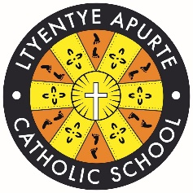 |  | School Newsletter 24th July 2023
Ltyentye Apurte Catholic School

Church Street, Santa Teresa, PMB 221, Via Alice Springs, NT, 0872.
Tel: (08) 8956 0937 email: justin.colley@nt.catholic.edu.au

Dear Families,


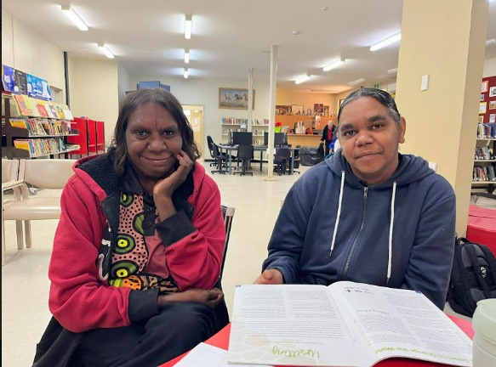
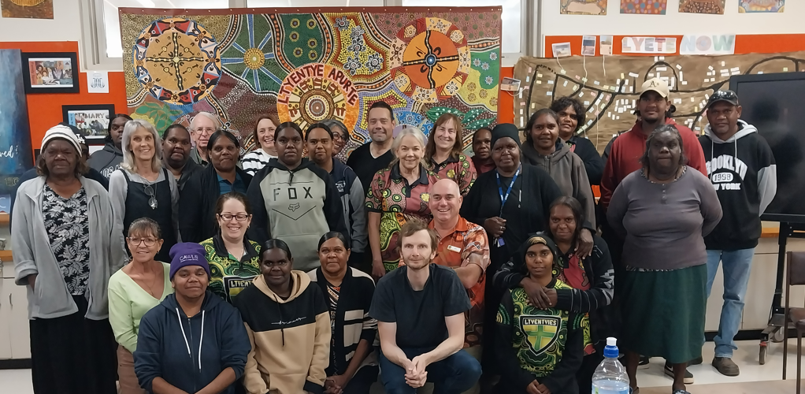
Welcome to Term 3! A warm welcome back to staff and students. The term started with a student free day where staff received Religious Education and first aid professional development. Elizabeth Falconer presented staff with information on The Marist Way 2023 theme: Created + Called. St John’s Ambulance also provided staff with first aid professional development on CPR. Your children are in safe hands.

NAIDOC Celebrations:
Every July, an important week is marked in Australia to recognise and celebrate the history, culture and achievements of Aboriginal and Torres Strait Islander peoples. NAIDOC is a chance for our community to gain a deeper understanding of Arrernte culture and build a united community. The 2023 NAIDOC theme is ‘For Our Elders’. An invitation is extended to all community members to join us for our NAIDOC celebrations on the school oval this Wednesday 26th.

Student Free Day: An additional Student-Free Day will be held on Monday July 31st. Staff will be involved in Curriculum Training on Child Protection and keeping kids safe. Ltyentye Apurte Catholic School will be closed that day for students however all staff are required to attend.

STRONG | CARING | RESPECTFUL

Special Awards Ceremony: Conratulations to those students who received awards at the 2023 Awards Ceremony. Students with attendance above 80% received a certificate and medallion. A Principal award was awarded to one student from each class who diplays the school values of being strong, caring and respectful. Well done students, you should be extremely proud of your achievements!

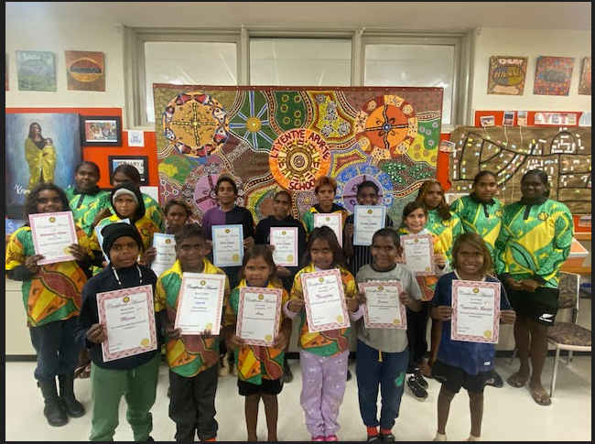
FAITH FOCUS (From our REC, Mr D)

 | Our thoughts and prayers are with Father Ollie following the death of his Mum. Eternal rest grant unto them, O Lord, and let perpetual light shine upon them. May the souls of the faithful departed, through the mercy of God, rest in peace.  Gospel Reflection: Glorious Word of God, You have sown Your seed of truth in our world, within Your Church and in my life. May I always listen to Your Word and respond to it wholeheartedly.

Important School Programs: Read Write Inc & SWPBS

 | Ltyentye Apurte Catholic School follows School Wide Positive Behaviour Support Approach to create a calm, positive and welcoming environment. The program teaches students social skills and socially acceptable behaviours. Teaching behavioural expectations and rewarding students for following them is a much more positive approach than waiting for misbehaviour to occur before responding.
 | Our students started Read Write Inc. this week. The program teaches children the sounds in English, the letters that represent them, and how to form the letters when writing. Many staff have had professional development in implementing the program and I know students will experience greater success in reading and writing. Thank you to Kaz and Cate for co-ordinating the program.

May God bless our students and families. Have a great week, everyone!

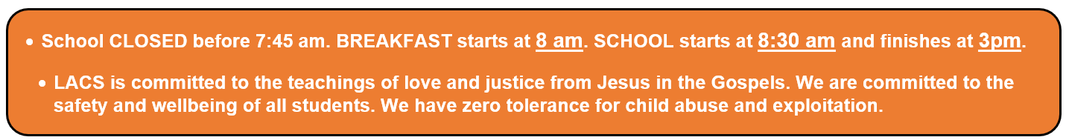
Mr. D

A / Principal


Confirmation and First Holy Communion Parent Information Session 2:00pm this Thursday (27th July) in the school staffroom. Please join us.
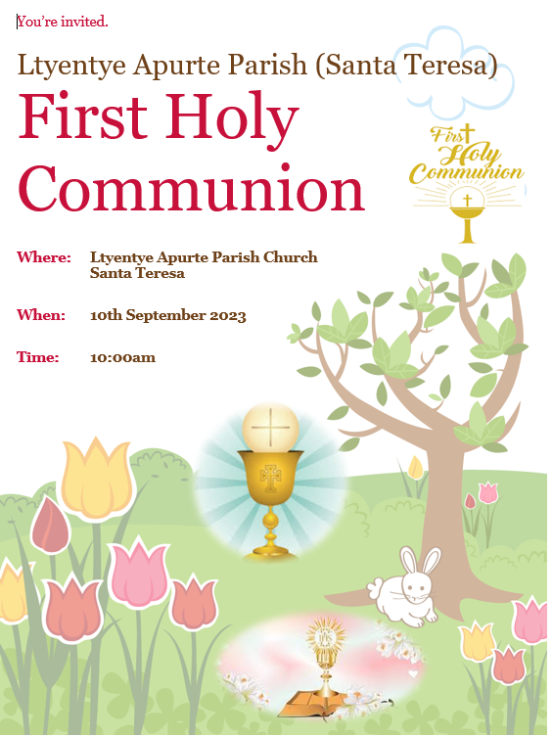

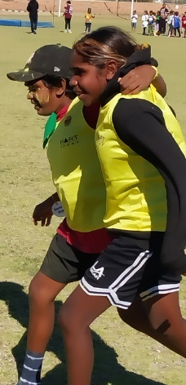

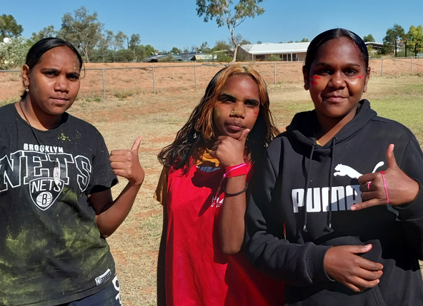
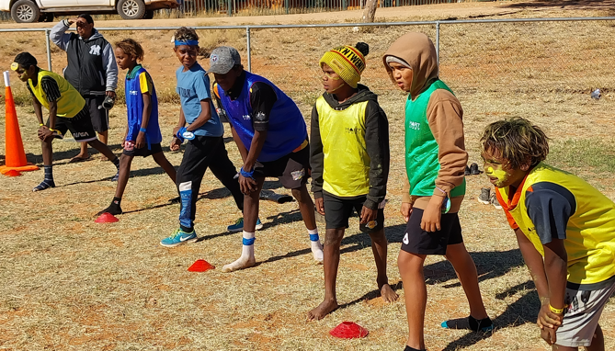
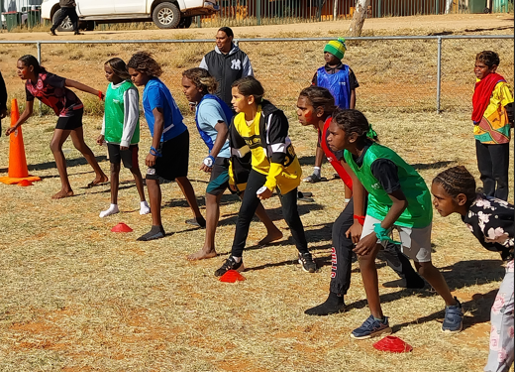
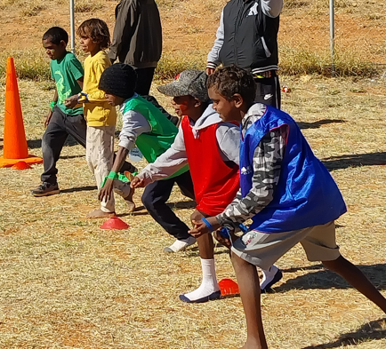

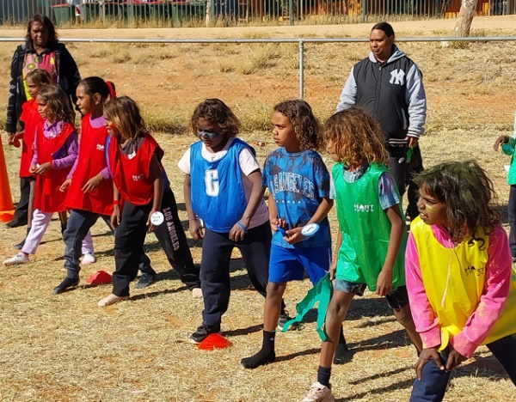
Sports Day
